39. Starting with SQL
#TOPIC 7- OUR FIRST DATABASE:
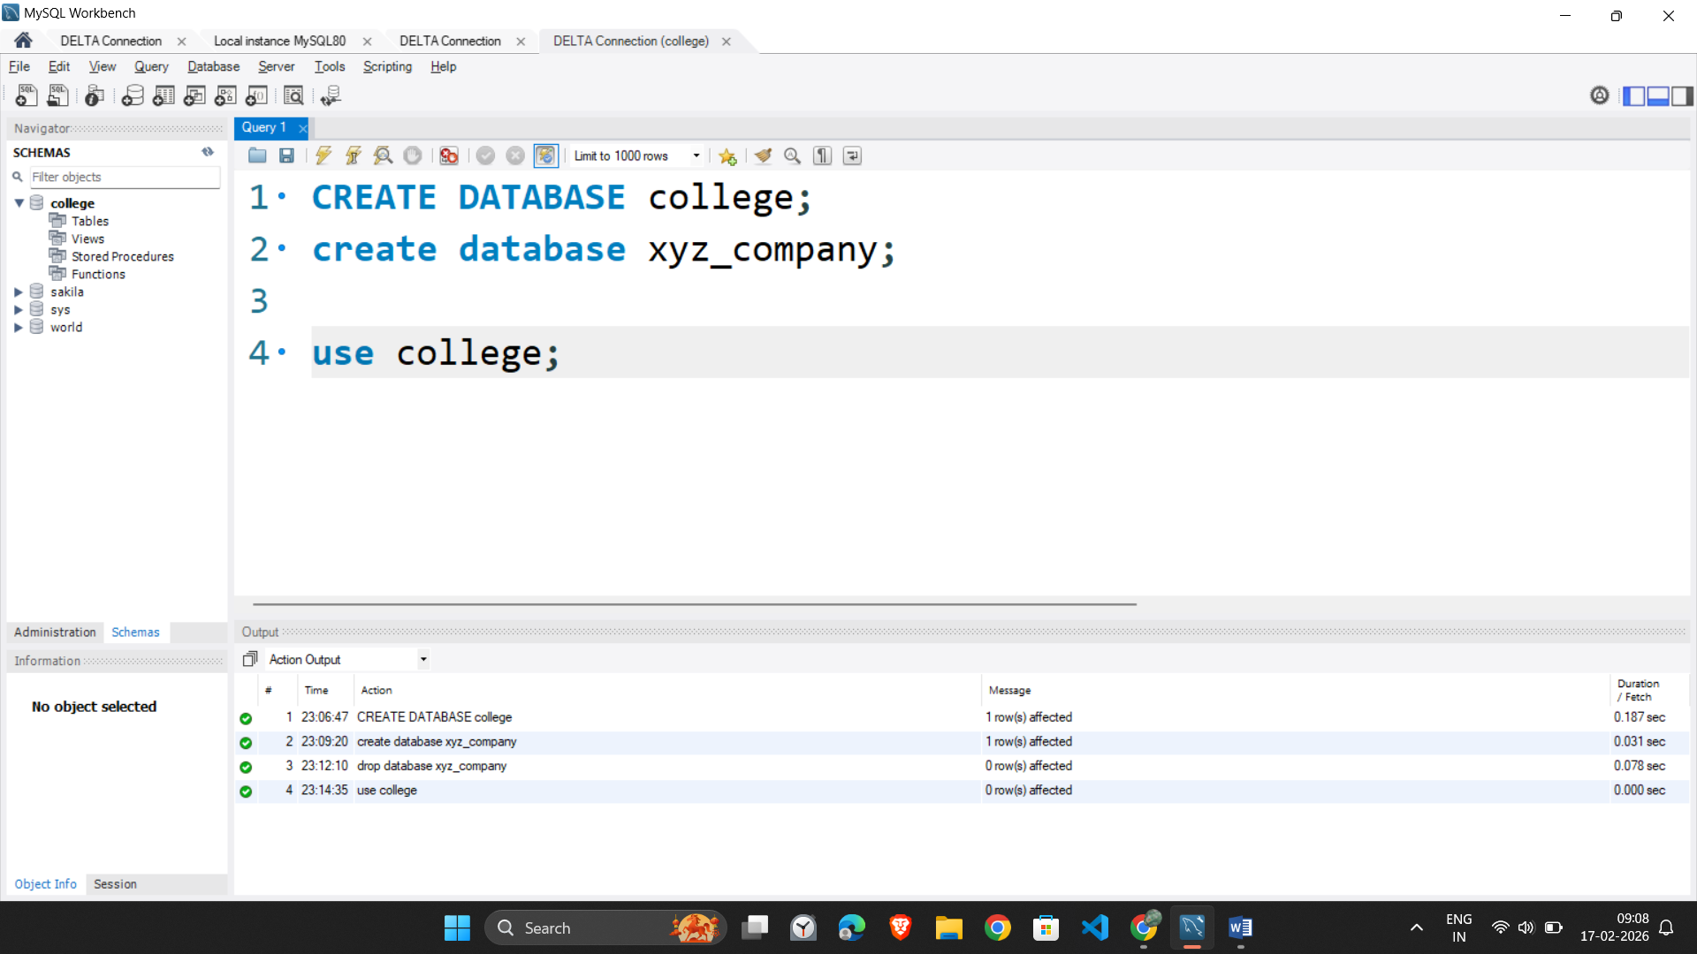
#Topic 8 –Our First Table :
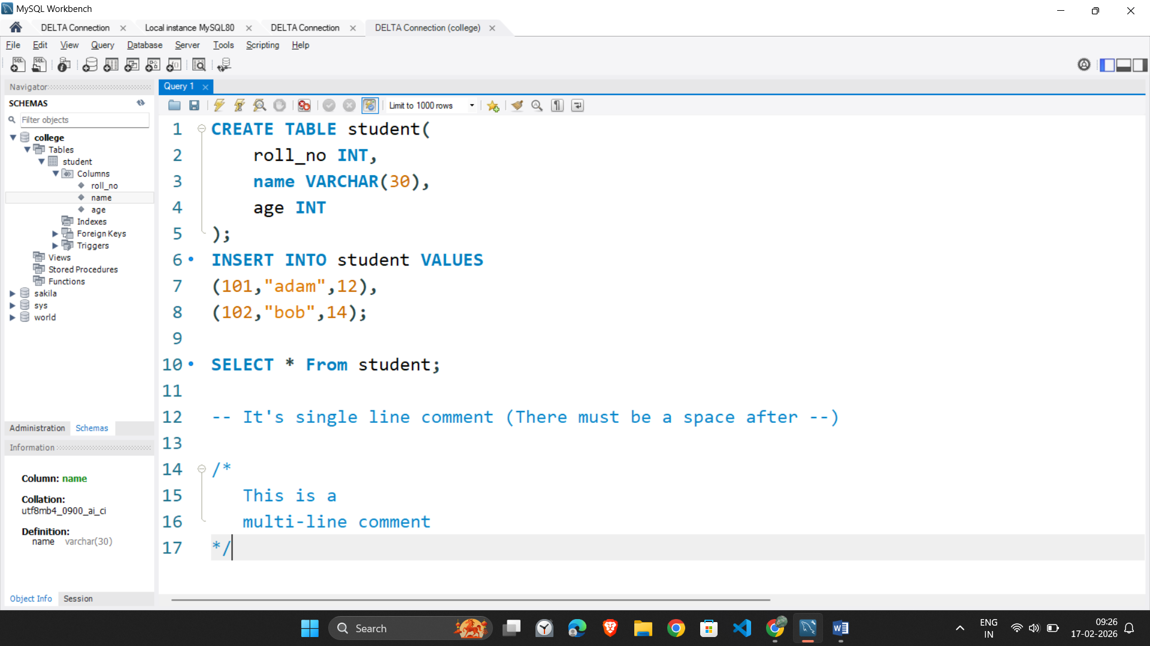
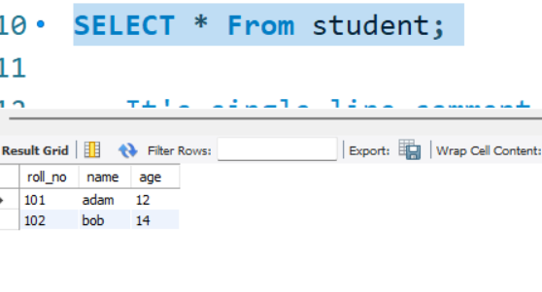
#Topic 9 Database Queries:
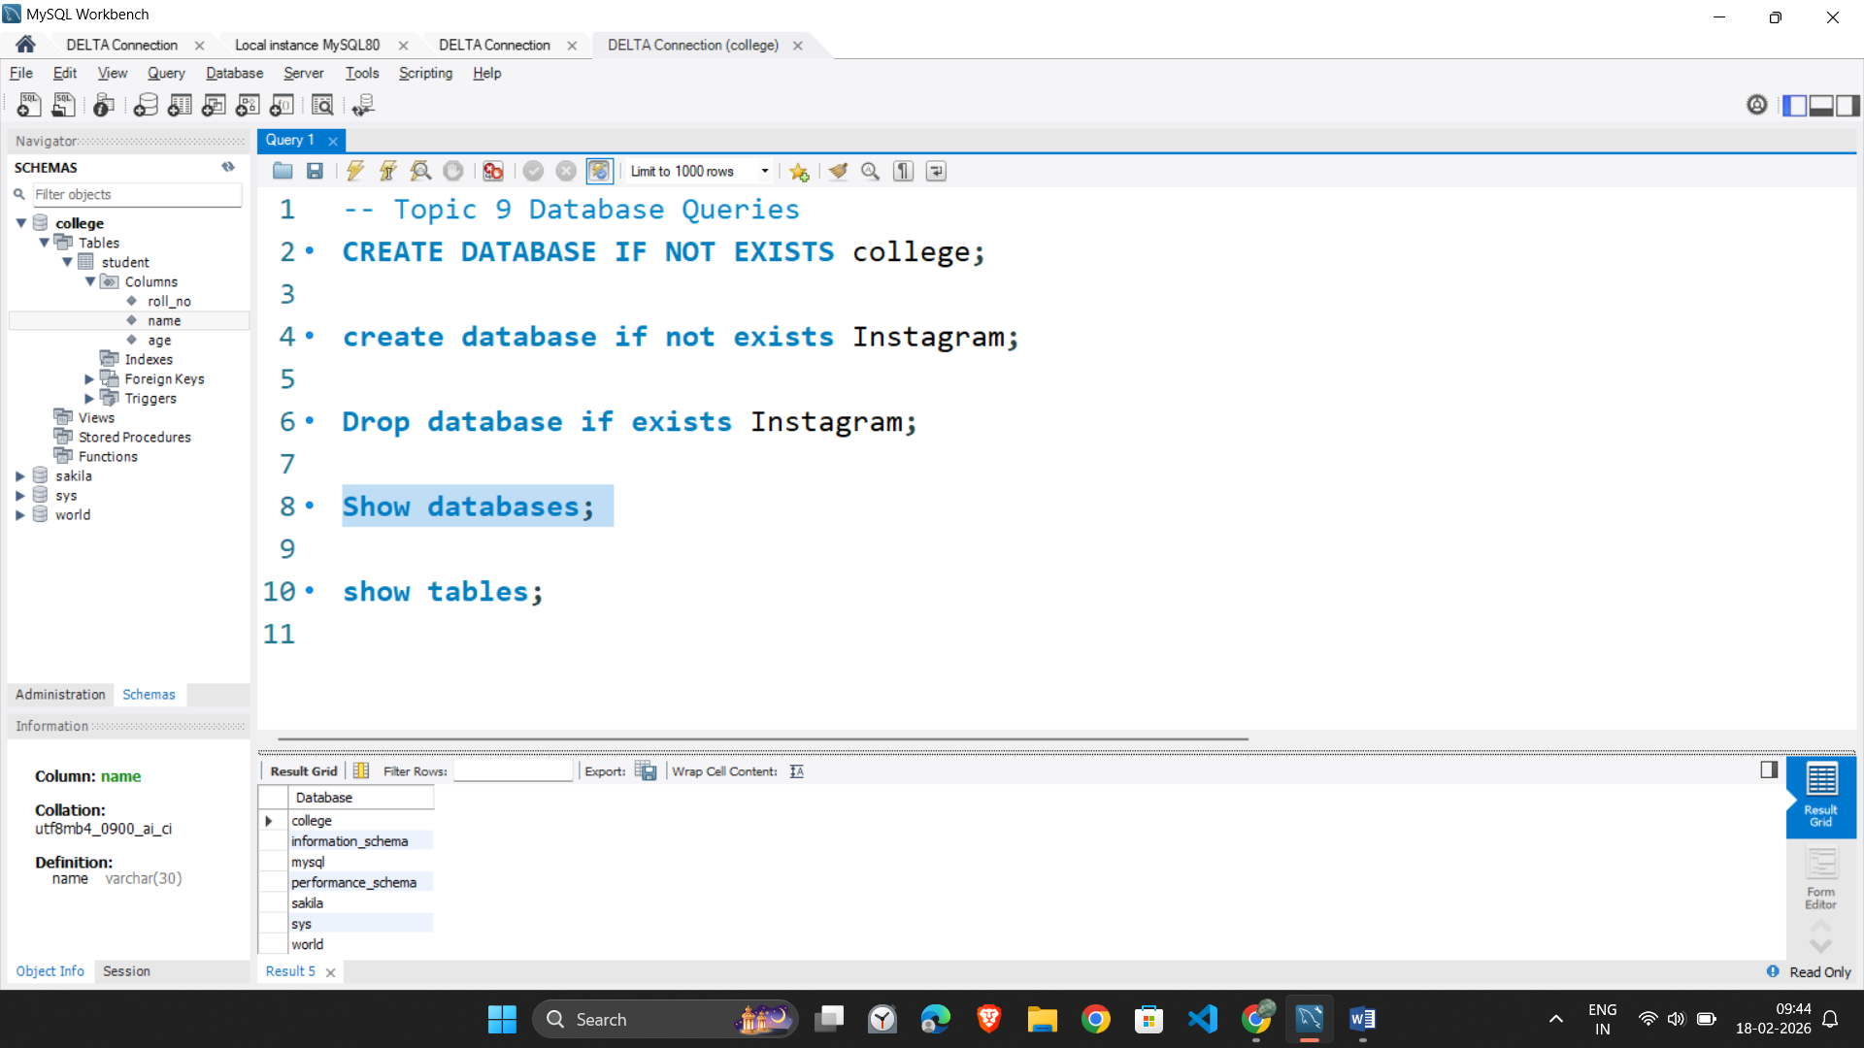
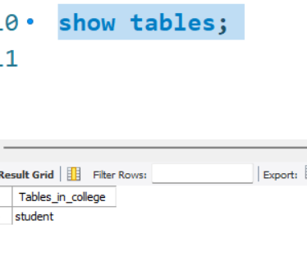
#Topic 10 – TABLE QUERIES: Create Table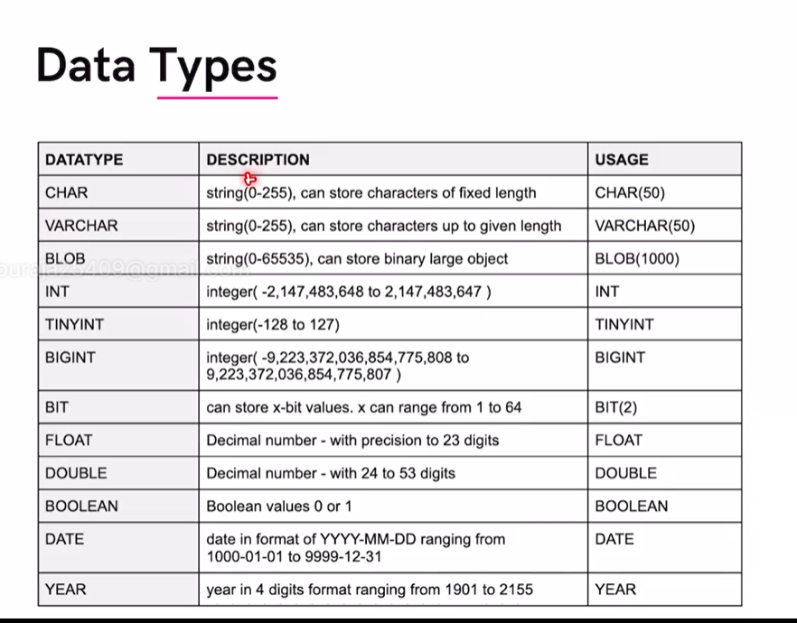 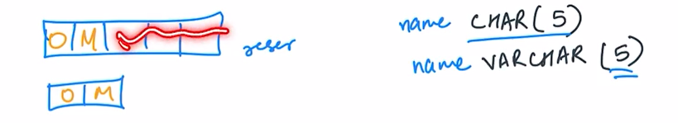
Char = fixed length data type
Varchar= variable length data type i.e can reduce length if requirement is less.

#Topic 11 What are constraints?
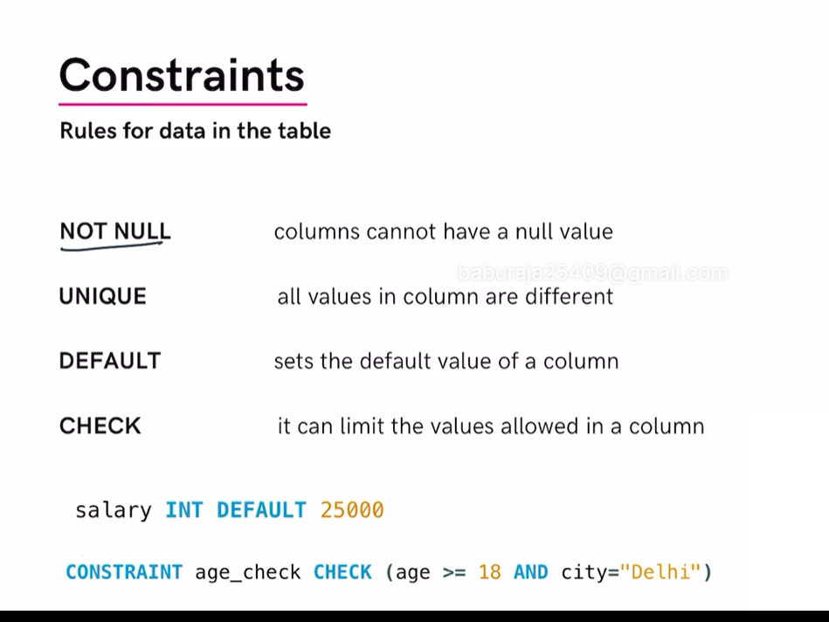
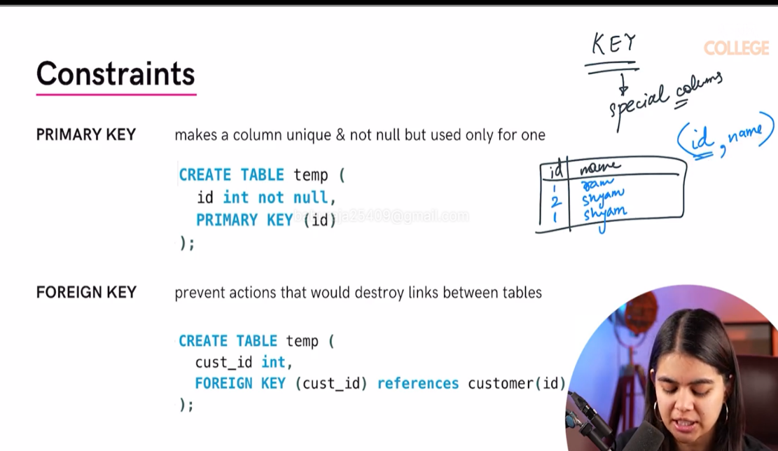
#Topic 12 Key Constraints

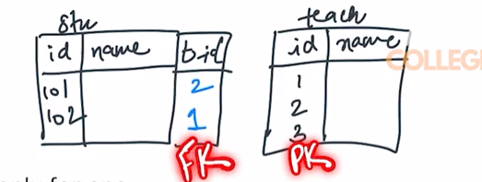
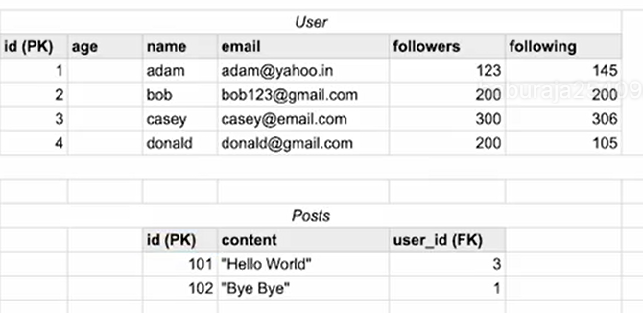
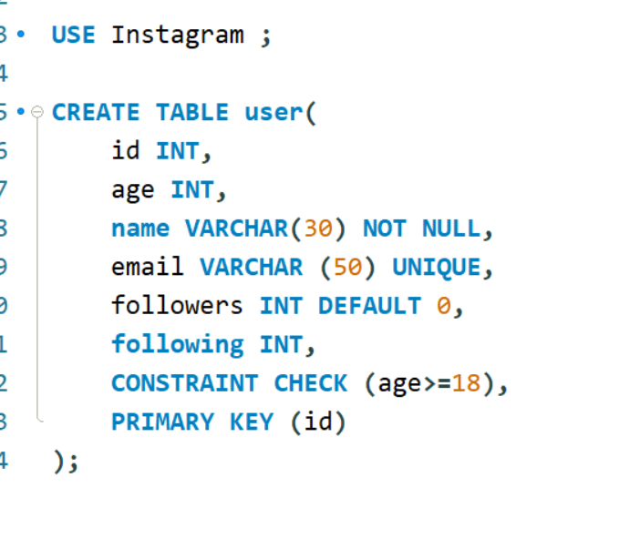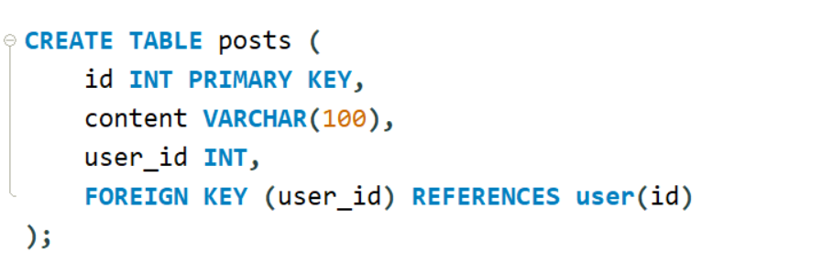
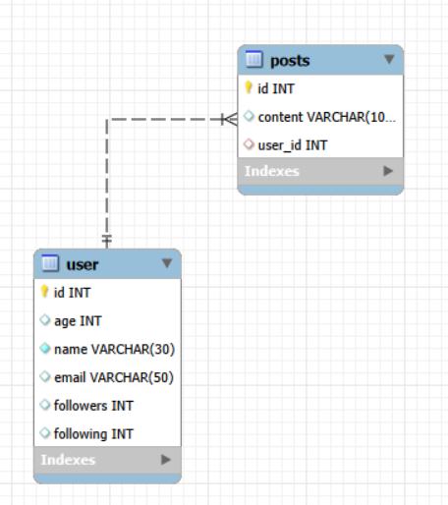
ER(Entity relation) Diagram
#TOPIC 13 Primary and Foreign Keys:
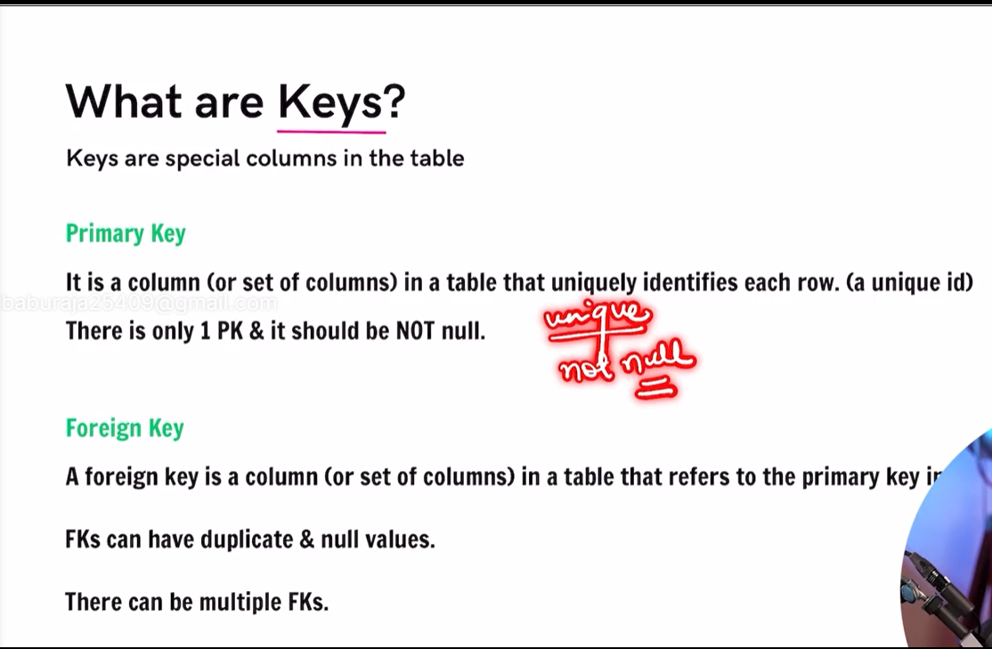
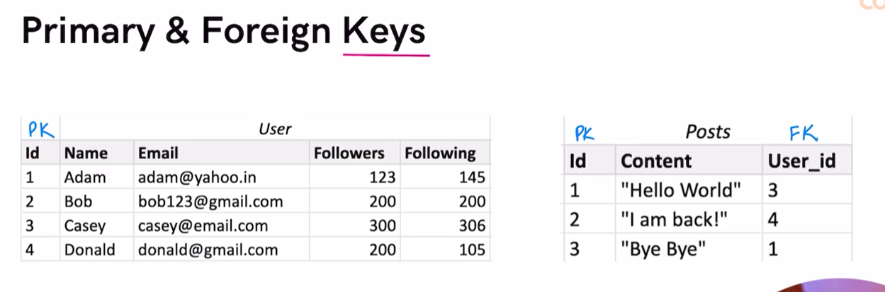

#Topic 14 INSERT into TABLE
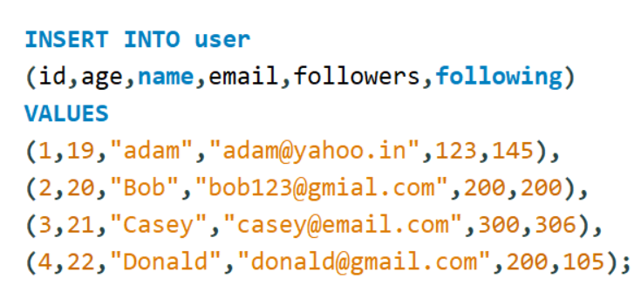
#Topic 15 SELECT command
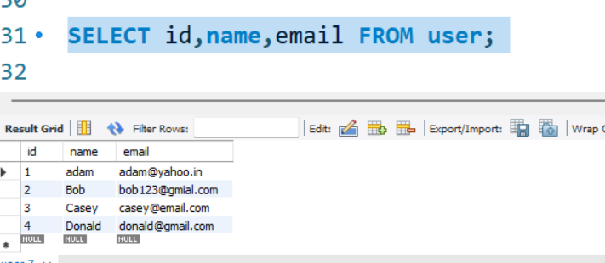
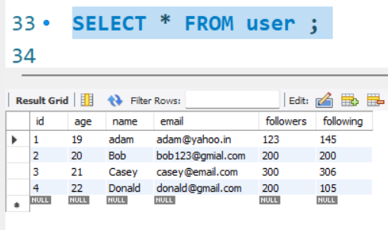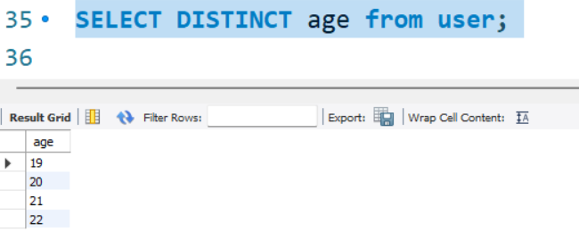
//DISTINCT WILL GIVE UNIQUE VALUES EXCLUDING DUPLICATE
40.SQL (Part – 2)
#Topic 1 WHERE CLAUSE:-
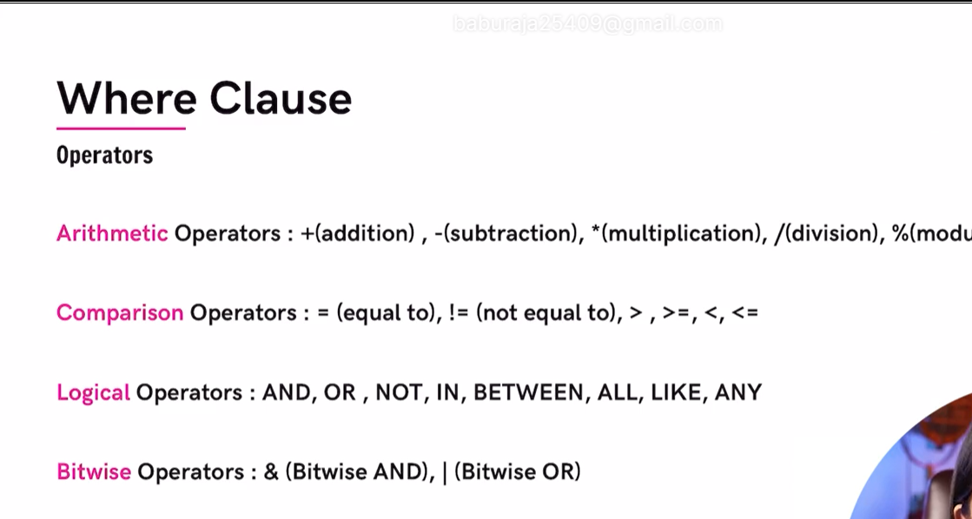
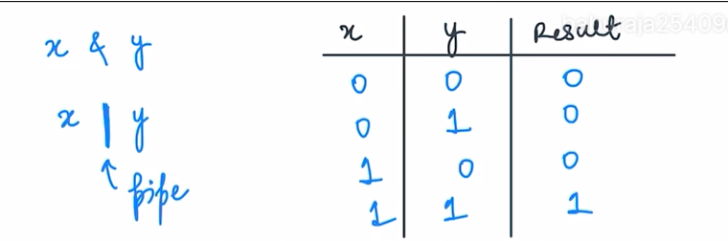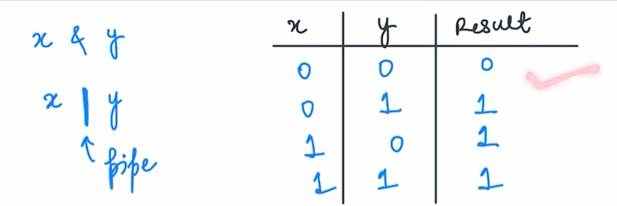
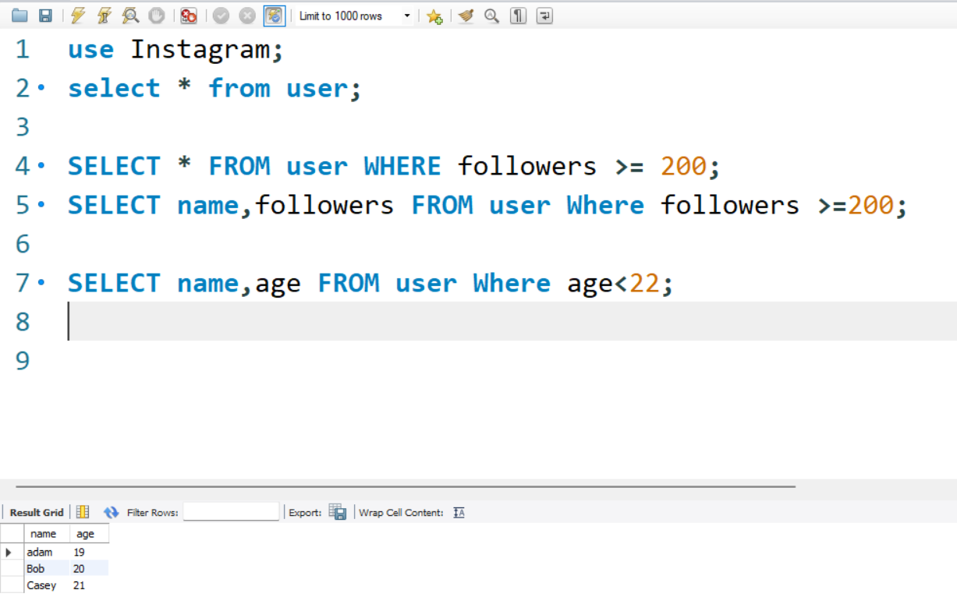
#Topic 3 Frequently used Operators:=
LOGICAL OPERATOR-

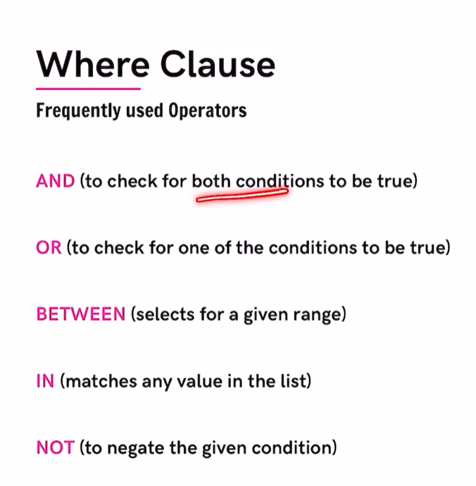
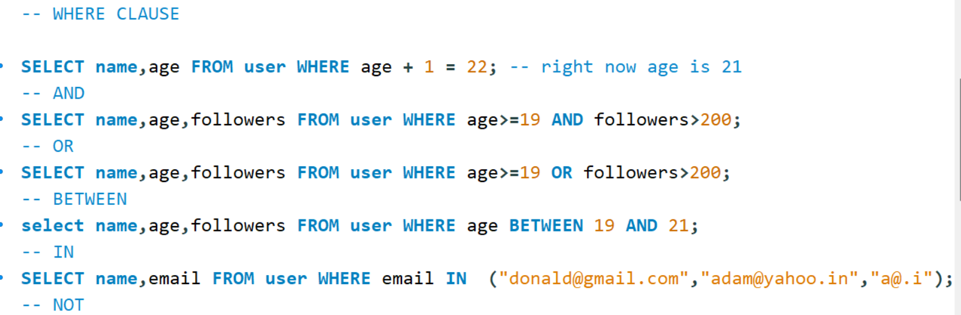
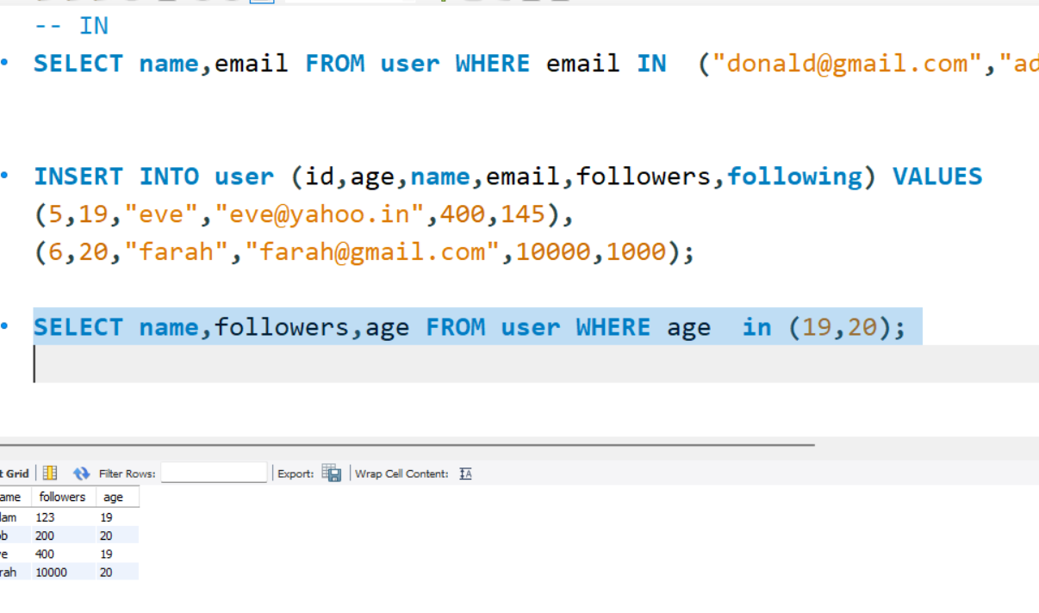
FROM HERE FOR SQL COMMANDS =SEE sql files in folder .

#TOPIC 6 – AGGREGATE FUNCTIONS
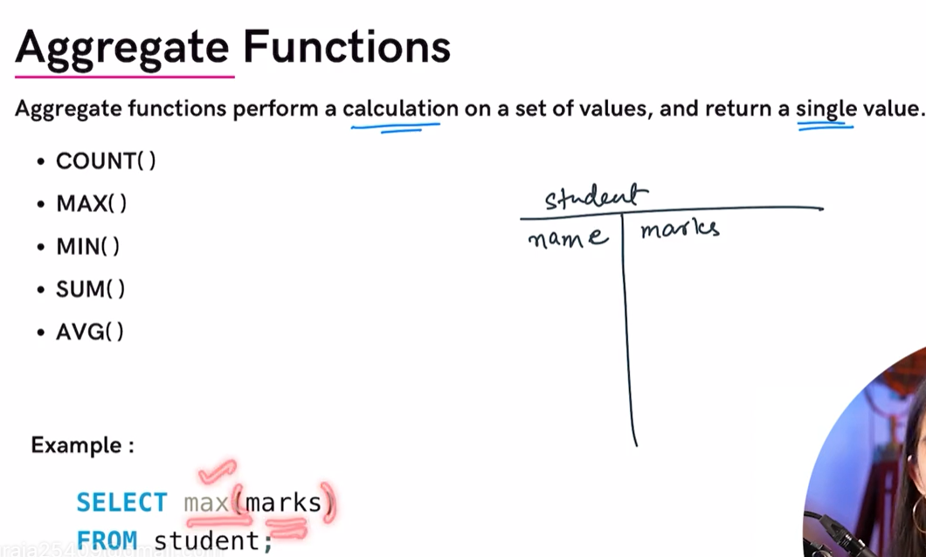

#TOPIC 7 GROUP BY CLAUSE
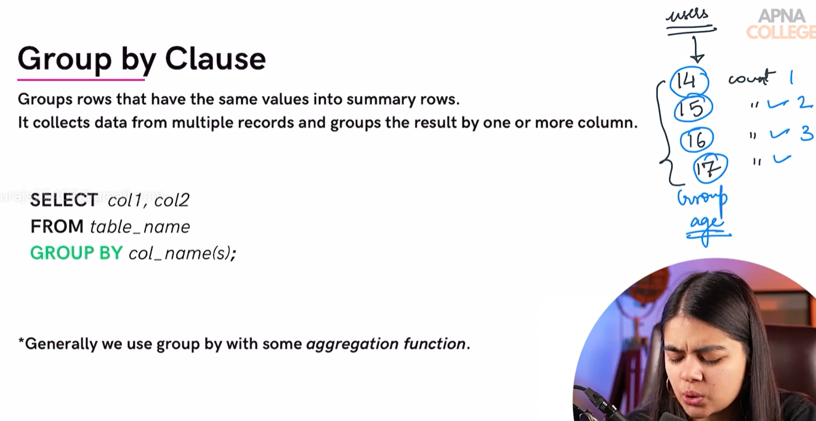
#TOPIC 8 HAVING CLAUSE
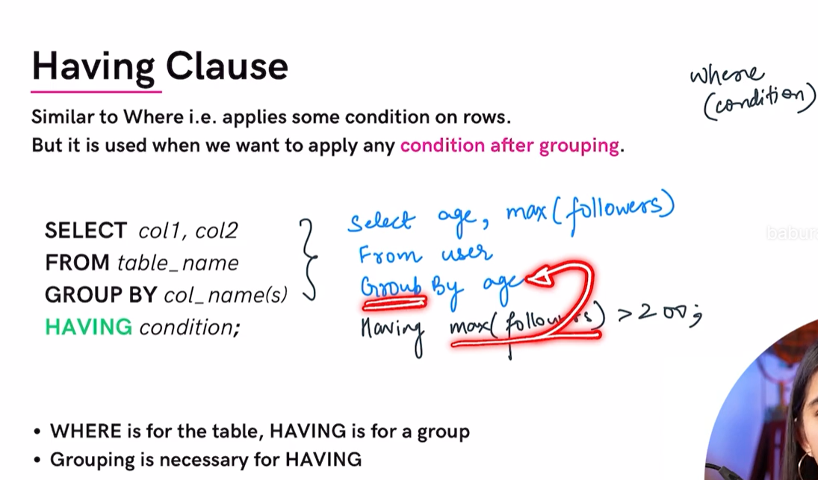

#TOPIC 9 GENERAL ORDER
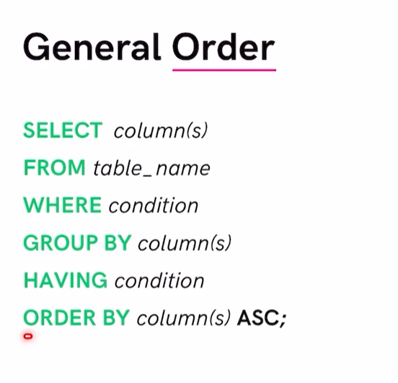

#TOPIC 10 UPDATE TABLE
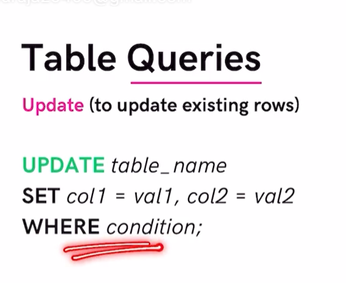
# TOPIC 11 DELETE TABLE
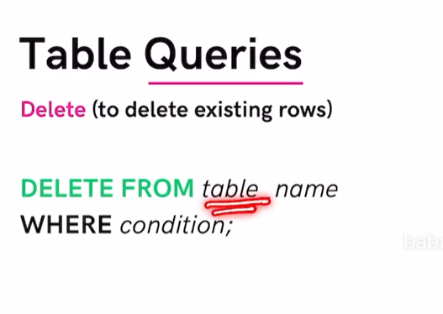
#TOPIC 12 ALTER TABLE
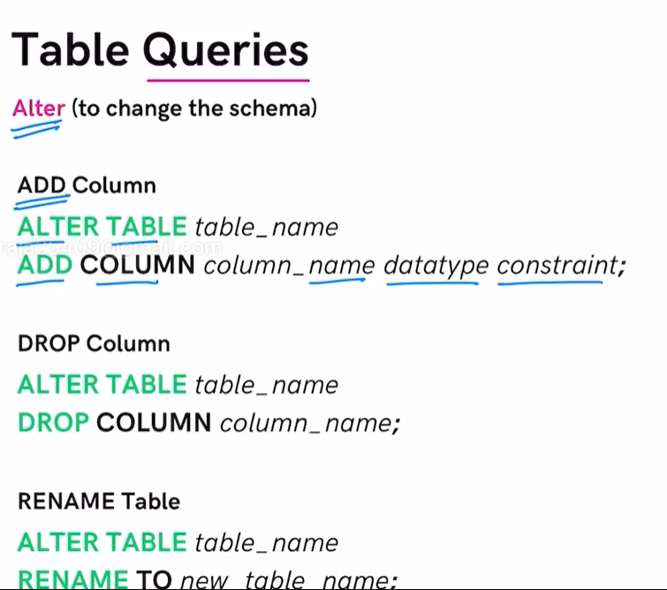
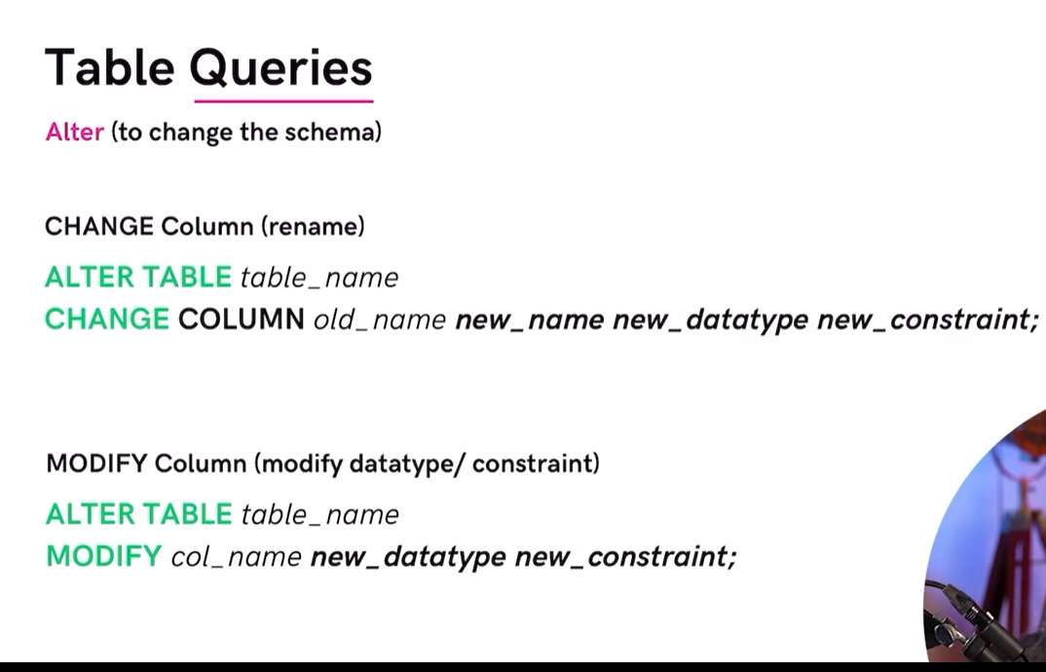

#TOPIC 13 TRUNCATE TABLE
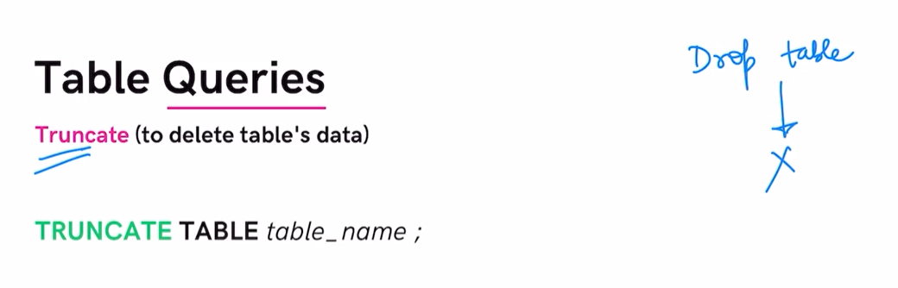
DROP-IT DELETES WHOLE TABLE
DELETE – TO DELETE EXISTING ROWS

#TOPIC 14 – PRACTICE QS 1

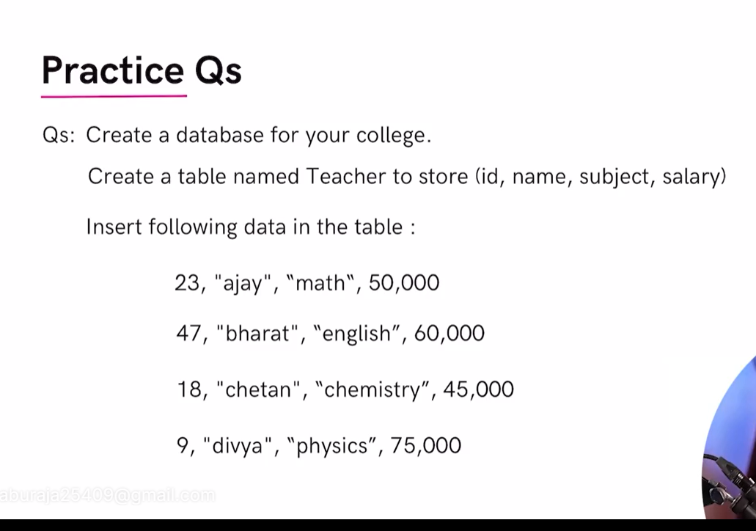
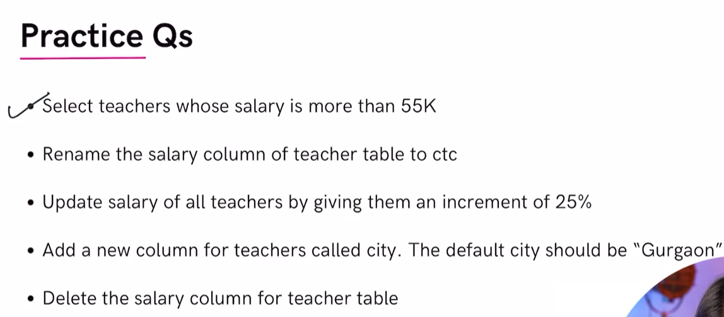

#TOPIC 15 PRACTICE QS 2
